**Schiedel offers powerful customer service for BIM, architecture and plant engineering with 3D CAD BIM library from CADENAS**

Several assemblies in all important CAD formats always available up-to-date and compatible

**Augsburg, Germany, 10th June 2016.** The company was founded in 1946 and is one of the leading manufacturers for exhaust gas systems in new buildings. Energy efficiency is of primary importance. Therefore efficiency should also be possible for the customers’ design process. This is why the company decided for CADENAS’ Electronic Product Catalog, to improve its BIM area for tendered architecture projects, plant engineering etc.

**Work faster and easier with current data**

The Electronic Product Catalog – based on the eCATALOGsolutions technology – and access to the 3D CAD download portal <http://schiedel.partcommunity.com> are the basis for Schiedel customer service on a grand scale. “Primarily, we want engineers, planners and architects to have a significant influence on the choice of the chimney at the beginning of the planning process. With an Electronic Product Catalog, working as a 3D CAD library, this is a lot easier, since data is always up-to-date and correct“, Herbert Pühringer explains, who is responsible for the design area and 3D BIM CAD libraries at Schiedel.

**Download BIM- and AEC CAD data around the clock**

Currently the double-wall system ICS25 is available as downlaod. Schiedel ICS is a double-walled stainless steel exhaust system with continuous modular-type insulation, suitable for exhaust gas routing from fireplaces with gaseous, liquid and solid fuels.

All BIM- and AEC CAD formats, like Autodesk Revit, Nemetschek Allpan and Grafisoft Archicad for the respective CAD systems and purposes, are available to engineers, planners and purchasers.

Regardless of location and time, customers can access data, download or select 3D BIM CAD models immediately during a consultation meeting. It is also ensured that the products can be provided in all current languages.

Further 3D BIM CAD libraries for stainless steel and ceramic chimneys as well as Kingfire furnace systems are being planned.

**3D visualization with dimensioning**

Depending on the application, components can be perfectly selected as individual parts or configurable assemblies (in preparation for the ceramic chimney sector). The web visualization in 3D with dimensioning is possible as well as the usual 2D view.

**Virtual reality supports the imagination of architects and planners**

As an additional highlight, engineers can use the virtual reality feature of the interactive product catalog. With a cardboard viewer and smartphones, architects can look at 3D models. This supports the imagination of users and Schiedel products can be experienced more easily.

**Topicality and compatibility**

The major bonus point for Schiedel customers is CADENAS as a powerful ally. The software developer from Augsburg ensures topicality. Moreover, compatibility is guaranteed with all important CAD systems and versions of the included BIM- and AEC CAD data in the Electronic Product Catalog.

**Long-term experience builds confidence**

So far, components have been perfectly prepared for users, however we are still on “level one“, says Jürgen Heimbach, CEO at CADENAS. Further extension and development will follow.

Herbert Pühringer explains why the cooperation between Schiedel and CADENAS is not without reason: “We have known CADENAS for a long time. In our internal design, we often work with components form diverse electronic catalogs“, he confirms. “Moreover CADENAS is one of the few providers of 3D CAD objects for mechanical engineering (plant engineering) as well as architecture (BIM). This way we kill two birds with one stone.“

**Press Images:**

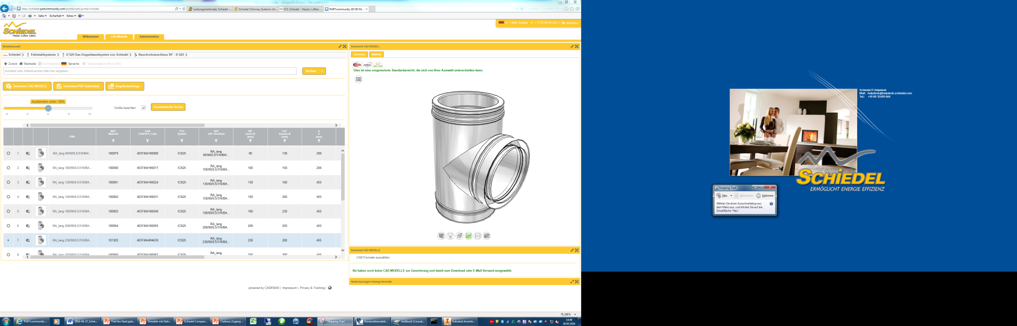

**Caption 1:** Regardless of location and time, customers can access data, download or select 3D BIM CAD models immediately during a consultation meeting.

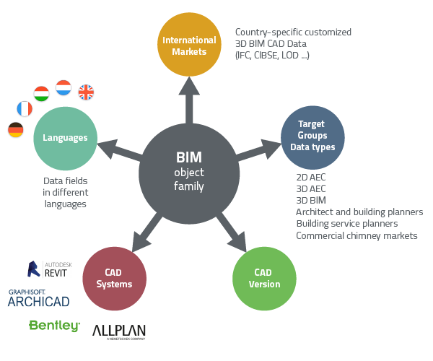

**Caption 2:** All BIM- and AEC CAD formats, like Autodesk Revit, Nemetschek Allpan and Grafisoft Archicad for the respective CAD systems and purposes, are available to engineers, planners and purchasers.

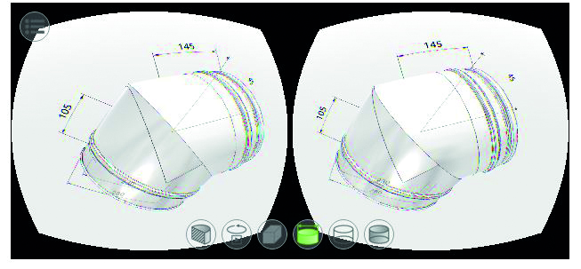

**Caption 3:** With a cardboard viewer and smartphones, architects can look at 3D models.

This press release and accompanying images are available for download from our website: [www.cadenas.de/press/press-releases](http://www.cadenas.de/press/press-releases)

**About CADENAS**

CADENAS is a leading software developer in the areas of Strategic Parts Management and parts reduction (PARTsolutions), as well as Electronic Product Catalogs (eCATALOGsolutions). With its customized software solutions, the company acts as a link between the component manufacturers with their products and the purchasers.

With its 300 employees at 17 international subsidiaries, the name CADENAS (Hispanic: process chains) has been standing for success, creativity, support and process optimization since 1992.

For further information, please visit: www.cadenas.de/en